How to read a touch position from a 4 wire touchscreen

How does a touch screen works:
You can see below the resistor network a touchscreen consist of.
This screen shot is from the ADS7843 touch controller and shows how it looks like.
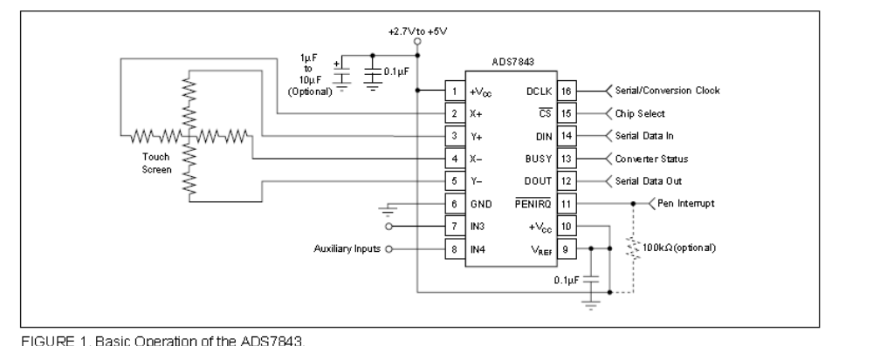

when we only look at the y direction of screen we have the following:
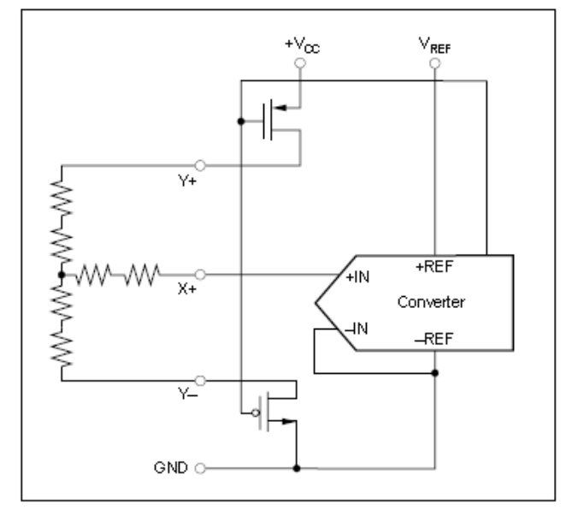
You can see some MOSFET. One is switching to 5 volts and the other makes the ground line.
So on the half of the touch – resistor in x direction we can measure the voltage produced by the two resistors of touch screen in y direction.
Its voltage corresponds to the y touch position, and will go from a little above 0V upt to a little below 5 Volt.
Looks easy, isn’t it..
But the touchpannel has got also a relative big capacity in parallel to the resistors.
That will cause voltage swing on X+ when we put 5 Volts on Y+!
To avoid long times for wainting the voltage goes to its normal value (resitor divider), we also put a FET on the X+ wire to short the wire for a certain time.
After this very short time we remove the FET (switch it off) and measure the voltage with the ADC Pin of the ATMEGA controller.

Here is a scope print of the X+ wire when a touch press is made.

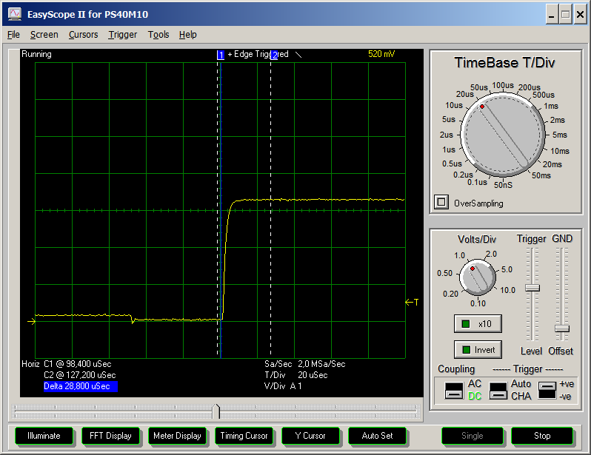

As you can see there is also a delay in time when the FET,which shorts the X+ pin to ground, is opened. In my application there is a maximum delay time of 20µs to measure.

How to we get touch positions from the ATMEGA processor:

Maybe it sounds difficult, but is realy easy.
First we connect the the 4 pins from the ADC to the touch panel.
See this picture:
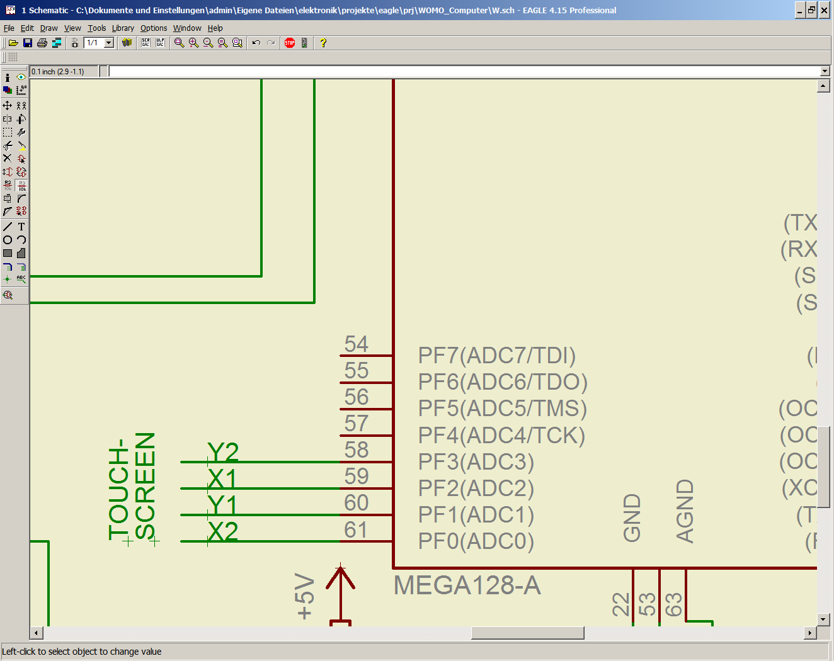
There is no need to put additional capacitors on the ADC inputs!
Only be shure that the wires are as short as possible and away from switching sources, to avoid noise.
Here are code samples from my touch.c , touch.h files:

Touch.h :

// Defines the port and port pins where the resistive touch screen is connected
#define ADC_PORT PORTF
#define TOUCH_Y1 2
#define TOUCH_Y2 0
#define TOUCH_X2 1
#define TOUCH_X1 3

typedef struct
{
unsigned char sleep; // sleep = 1 turns on ADC before and off ADC after read the touch position
unsigned int offset_x; // ADC results for minimum position in x direction
unsigned int offset_y; // ADC results for minimum position in y direction
unsigned int scale_x; // scale factor for calculating x direction
unsigned int scale_y; // scale factor for calculating y direction
} ctouch_t;

extern ctouch_t touch; // configuration data se typedef

typedef struct
{
unsigned char x1, x2, y1, y2;
} button_t;

touch.c:

#define MAXBUTTON 32
#define TS_VERSION 110 // version of Settings Data

point_t touch_pos; // the result of the x and y position of called function read_touch
point_t adc_min;
ctouch_t touch; // configuration data se typedef
ctouch_t dummy;

uint8_t ee_version __attribute__ ((section (".eeprom")));
ctouch_t ee_touch __attribute__ ((section (".eeprom"))); // settingsdata from eeprom

button_t buttons[MAXBUTTON]; // Array of buttoncoordinates
uint8_t max_button; // number of declared buttons

int8_t read_touch_settings(void);

// initializes adc and sets parameter for turning on and off acd every adc read
// adc_off = 1 turns on ADC before and off ADC after read the touch position
int8_t touch_init(uint8_t adc_off)
{
touch.sleep = adc_off;
/* touch.scale_x = 387;
touch.scale_y = 407;
touch.offset_x = 139;
touch.offset_y = 405; */
a2dInit();
if (touch.sleep) a2dOff();
*(&ADC_PORT -1) |= (1<<TOUCH_X1) | (1 << TOUCH_X2) | (1<< TOUCH_Y1) | (1<< TOUCH_Y2); // define all for outputs

return(read_touch_settings());
}
// reads the touch pannels adc inputs in x and y direction
// if touchscreen is configered it calculates it screen position in touch_pos structure
int8_t read_touch(void)
{
if (touch.sleep) a2dOn();
int8_t result=0;
ADC_PORT |= (1<<TOUCH_X1); // put 5 volt an TOUCH_X1 and 0V on TOUCH_X2
_delay_us(100); // delay cause touchpad is like a capacitor
#ifdef AD_ON
*(&ADC_PORT -1) &= ~((1<< TOUCH_Y1) | (1<< TOUCH_Y2)); // inputs for measuring wires
_delay_us(40); // time delay for signal to settle
touch_pos.x = a2dConvert10bit(TOUCH_Y2); // read voltage of X direction
#else
touch_pos.x = 512;
#endif
ADC_PORT &= ~(1 <<TOUCH_X1); // deactivate pullup
*(&ADC_PORT -1) |= (1<<TOUCH_X1) | (1 << TOUCH_X2) | (1<< TOUCH_Y1) | (1<< TOUCH_Y2); // define all for outputs
if (touch_pos.x > touch.offset_x)
{
ADC_PORT |= (1<< TOUCH_Y1); // put 5 volt an TOUCH_Y1 and 0V on TOUCH_Y2
_delay_us(100); // delay cause touchpad is like a capacitor
*(&ADC_PORT -1) &= ~((1<<TOUCH_X1) | (1 << TOUCH_X2)); // put them as input port pins again
#ifdef AD_ON
_delay_us(40); // time delay for signal to settle
touch_pos.y = a2dConvert10bit(TOUCH_X2); // read voltage of Y direction
#else
touch_pos.y=512;
#endif
ADC_PORT &= ~(1 <<TOUCH_Y1); // deactivate pullup
*(&ADC_PORT -1) |= (1<<TOUCH_X1) | (1 << TOUCH_X2) | (1<< TOUCH_Y1) | (1<< TOUCH_Y2); // define all for outputs
if (touch_pos.y > touch.offset_y)
{
result =1;
// a touch has been recognized -> calculate the display position if possible
if ((touch.scale_x != 0) && (touch.scale_y != 0))
{
if (touch_pos.x > touch.offset_x) touch_pos.x -= touch.offset_x; // remove adc offset for position 0
else touch_pos.x =0;
if (touch_pos.y > touch.offset_y) touch_pos.y -= touch.offset_y;
else touch_pos.y=0;
touch_pos.x = (unsigned long) touch_pos.x * touch.scale_x /1000;
touch_pos.y = (unsigned long) touch_pos.y * touch.scale_y /1000;
} else result = -1; // calculation not possible
}
}
if (touch.sleep) a2dOff();
return(result);
}

complete source files of touch.c are added to my project files listed below this document.

This source code is coupled with display messages for calibrating the touch parameters:

void calibrate_touchscreen(void)
{
static const char txt_touch1[] PROGMEM = {"TOUCH KALIBRIERUNG"};
static const char txt_touch2[] PROGMEM = {"Bitte berühre das Fadenkreuz"};
static const char txt_speichern[] PROGMEM = {"Daten speichern ?"};
static const char txt_ja[] PROGMEM = {"Ja"};
static const char txt_nein[] PROGMEM = {"Nein"};
static const char txt_gespeichert[] PROGMEM = {"gespeichert ...."};

point_t p1, p2;
// draw cross at position 1
p1.x = 20;
p1.y = 20;
lcd_print_cross(p1, 10, 10);
glcd_select_font(F_LARGE);
glcd_textP(txt_touch1,0,LEFT_VIEW,50,100,0);
glcd_textP(txt_touch2,0,LEFT_VIEW,60,0,0);

clear_settings(); // enable capturing adc values
capture_point(1); // capture first point
lcd_clrscrn(1);
delay_ms(300);
glcd_textP(txt_touch1,0,LEFT_VIEW,50,100,0);
glcd_textP(txt_touch2,0,LEFT_VIEW,0,217,0);

// draw cross at position 2
p2.x = PIXELX - 20;
p2.y = PIXELY - 20;
lcd_print_cross(p2, 10, 10);

capture_point(2); // capture second point
lcd_clrscrn(1);
calc_config(p1, p2);
glcd_textP(txt_speichern,0,LEFT_VIEW,80,100,0);
clear_areas();
add_button(100,130 ,txt_ja);
add_button(170,130, txt_nein);
delay_ms(1000);
int8_t res=capture_area() ;
clear_buttons();
if (res== 1)
{

glcd_textP(txt_gespeichert,0,LEFT_VIEW,80,120,0);
save_touch_settings();
delay_ms(500);
lcd_clrscrn(TXT_LAYER);
}
lcd_clrscrn(0);
}

Here are some pictures which shows screen image from calibrating the touch screen
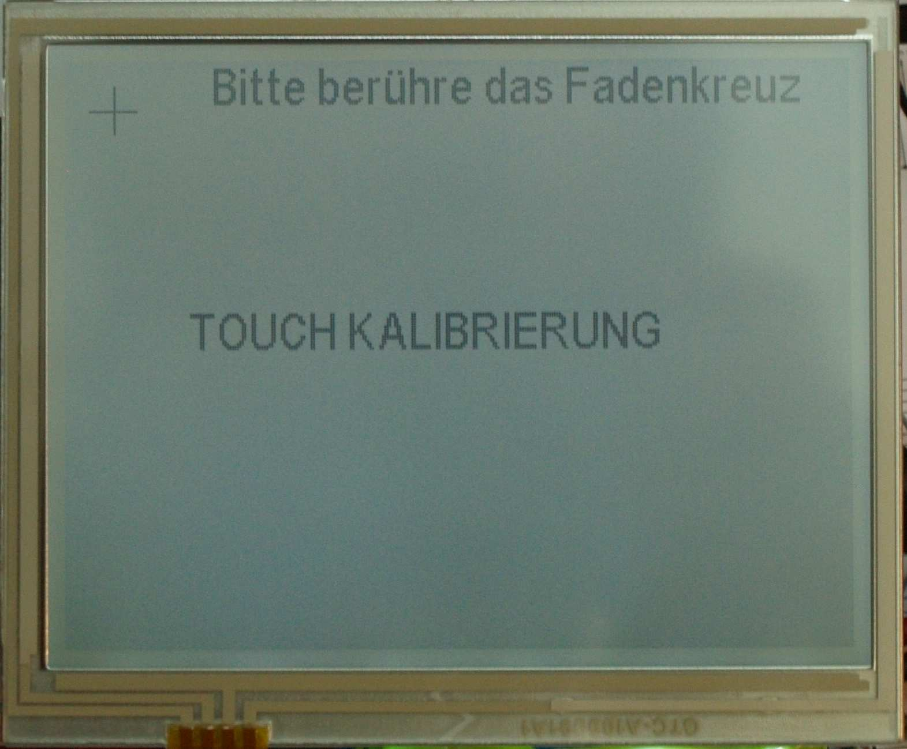

Beginning with the touch screen calibration :
First display text and cross of position to touch
After position has been touched and saved
NEXT


Display second point
And wait for touching it

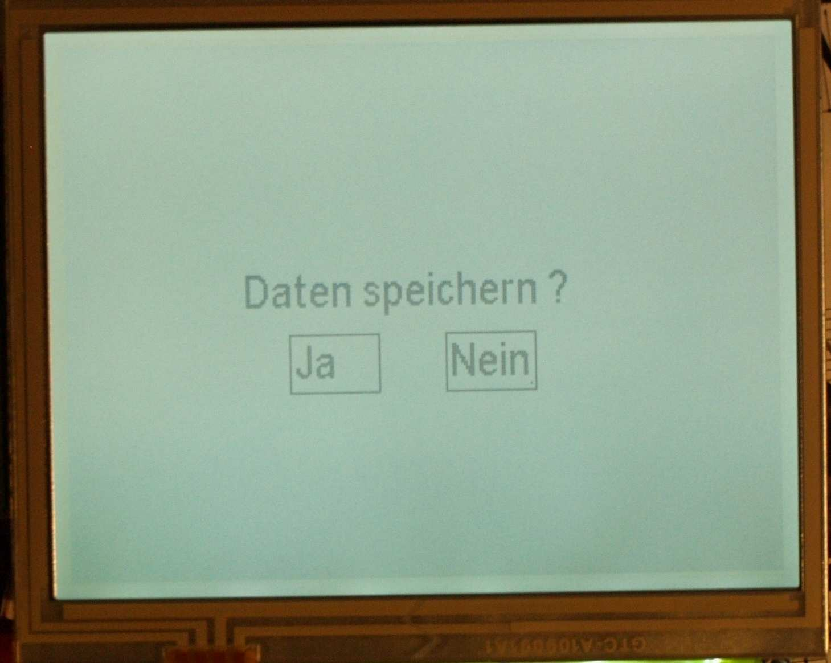

Asking for saving scale and offset parameter
to eeprom.

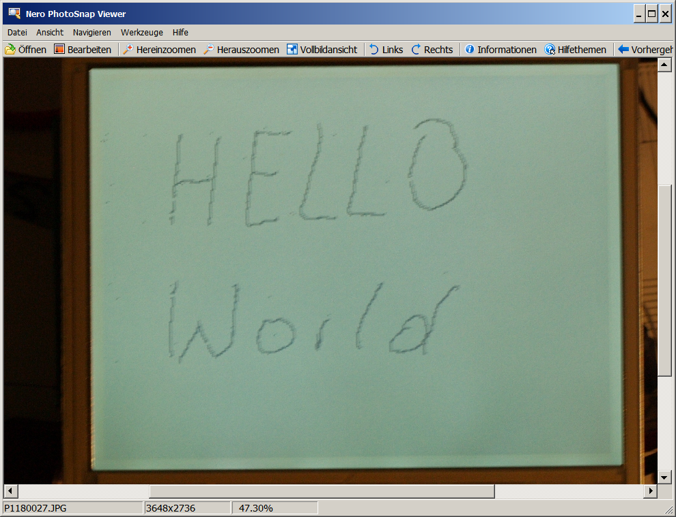
As you can see some dots on the left side, which came when writing the text with a pen on the touch screen. To avoid this dots to be printed the measured voltages must be filtered which cost lots of µseconds.

